# Travel Approval Report Template

1. INTRODUCTION:
   1. Overview:

When employees travel for company-related purposes,it is [Travel Approval Corporate]responsibility to provide safe and reliable travel arrangements.This company travel policy serves to clarify the conditions and parameters of a company-paid trip.

* 1. Purpose:

The purpose of this company travel policy is to,

1. outline the authorization and reimbursement process for travel arrangements and expenses,
2. to list the company-paid travel expenses,and
3. to establish protocols that oversee the travel arrangement process.
4. PROBLEM DEFINITION & DESIGN THINKING:
   1. Empathy Map:

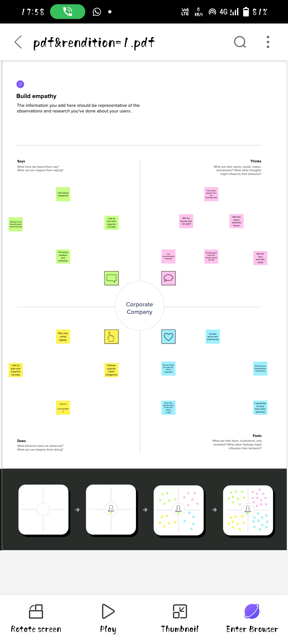

2.2 Ideation & Brainstoming Map

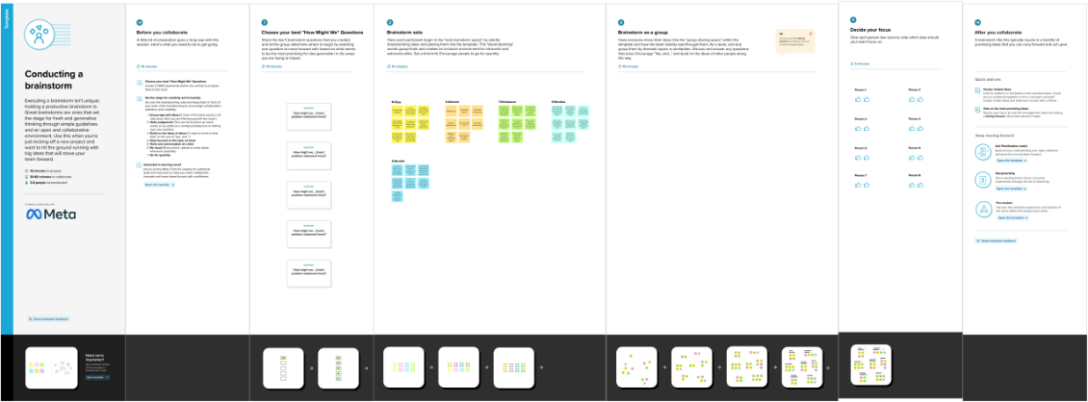

3.RESULT:

3.1Data Model:

Object Name:

Travel Approval

Field label Data type

1.Department Department Lookup

2.Total Expense Total Expense Roll-Up Summary

4.TRAILHEAD PROFILE PUBLIC URL:

1. Vijay.N - <https://trailblazer.me/id/vvijay217>

2. Abinesh.S - <https://trailblazer.me/id/ababi102>

3 .Dhinakaran.T - <https://trailblazer.me/id/jtoazasb>

4. Monisha.S - <https://trailblazer.me/id/Monisha>

5. Revathi.A - <https://trailblazer.me/id/aarevathi>

5.ADVANTAGES & DISADVANTAGES:

Advantages:

1. High passenger capacity,low energy consumption percapita and pollution ,good travel accessibility.
2. Low price,good travel accessibility,and convenient service.
3. Good travel accessibility ,high mancuverability ,large safety coefficient and high comfort level.
4. High passengers capacity and inexpensive price.

Disadvantage:

1. Uncertain service time and arrival time,low comfort level,and small safety coefficient.
2. Low flexiblity,moderate comfort level,and poor environmental atmosphere.
3. High price,with lots of service uncertainties.
4. Moderate comfort level,restricted air routes.

6.APPLICATIONS:

Salesforce Travel Approval trailhead

7.CONCLUSION:

While the business travel approval process may seem overwhelming when everything is done manually, this doesn’t have to be the case forever. By creating an organized plan, communicating it well, and using an automated, centralized system, you can change the way your company does business travel.

8.FUTURE SCOPE:

1. Duty of care is a hygiene factor for all business in travel approval
2. Well being policies by corporates drive employee satisfaction
3. Virtual interaction leads to a hybrid future in business
4. Remote work is here to stay with a globally distributed workforce in travel approval